# Test Exit Report

# 1.Purpose of this Document

This document explains various activities performed as part of the API testing for Hotel Booking End points.

# 2.Overview

Hotel Booking API Endpoints are automated as part of regression testing.

# 3.Testing Scope

**In-Scope**: API automation testing for following API functionalities.

1. Booking - CreateBooking
2. Booking - UpdateBooking
3. Booking- DeleteBooking

# 4.Type of Testing

**Regression Testing**: This can be performed for each time when any enhancement or requirement change to existing API functionality.

# 5.API details and Test Tools

**API Documentation**: [http://restful-booker.herokuapp.com/apidoc/index.html#api-Booking-GetBookings](http://restful-booker.herokuapp.com/apidoc/index.html%23api-Booking-GetBookings)

**Automation Test suite prepared using**:

1. REST assured library – to test REST API using java libraries
2. TestNg – Testing framework
3. Maven – Build Tool
4. Eclipse – IDE
5. JAVA – Programming language

# 6.Test Result

Following is the API automation test execution report generated using TestNg framework

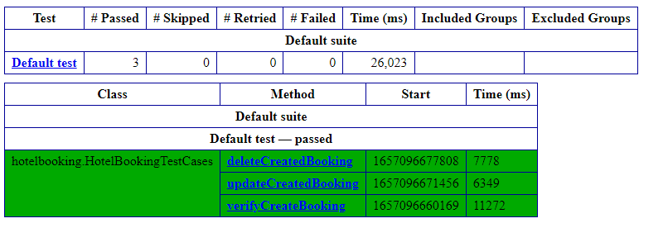

Test Results displayed in console(logs)

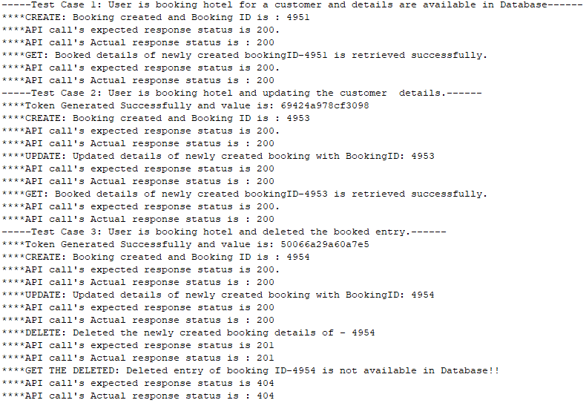

# 7.Lessons Learned

Regression can be done with all test cases or for basic APIs using TestNg features.

# 8.Best Practices

1. Regression, smoke or sanity can be done using this automation suite when any new requirement changes occur.
2. Test suite should be maintained and updated when there is an impact on the regression functionalities.

# 9.Exit Criteria

All the cases are executed and in PASS status

# 10.Sign Off

As we met the exit criteria and satisfied with section 10, this APIs are suggested to ‘Go Live’ by testing team. Also suggesting to perform appropriate User/Business acceptance testing before ‘Go Live’.